**Step1 : Cloning sir mubashir’s repo and creating .env file . then adding projectid , dataset and TOken fields.**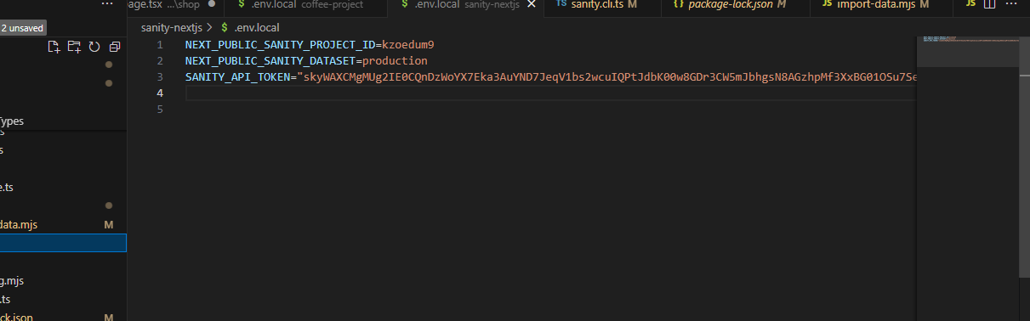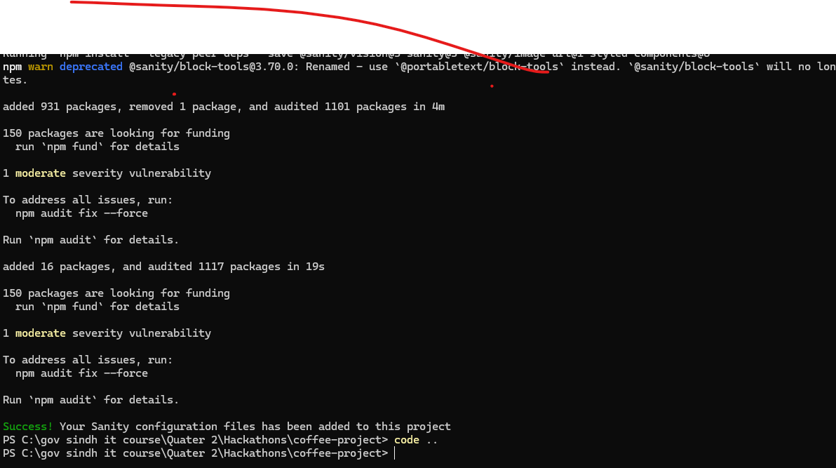

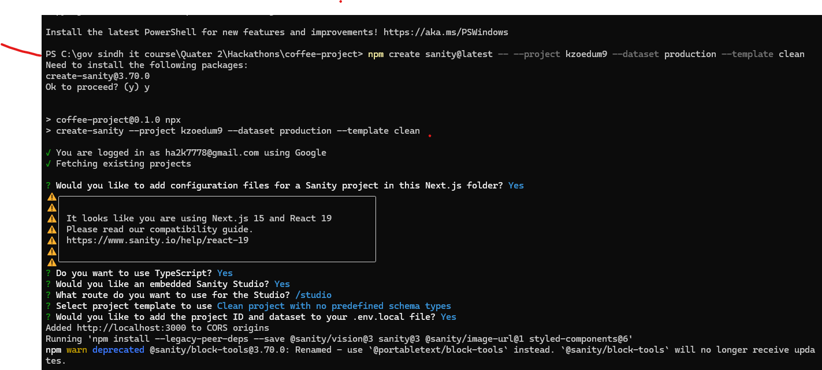

**Step2: importing data to sanity using the command”npm runimport-data”**

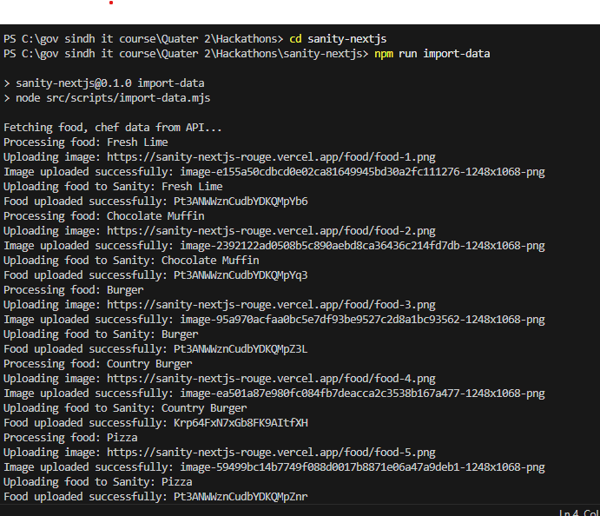

**Step3:verifying in the hackathon project that data is successfully imported.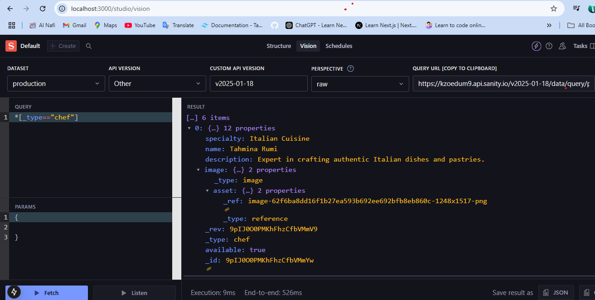**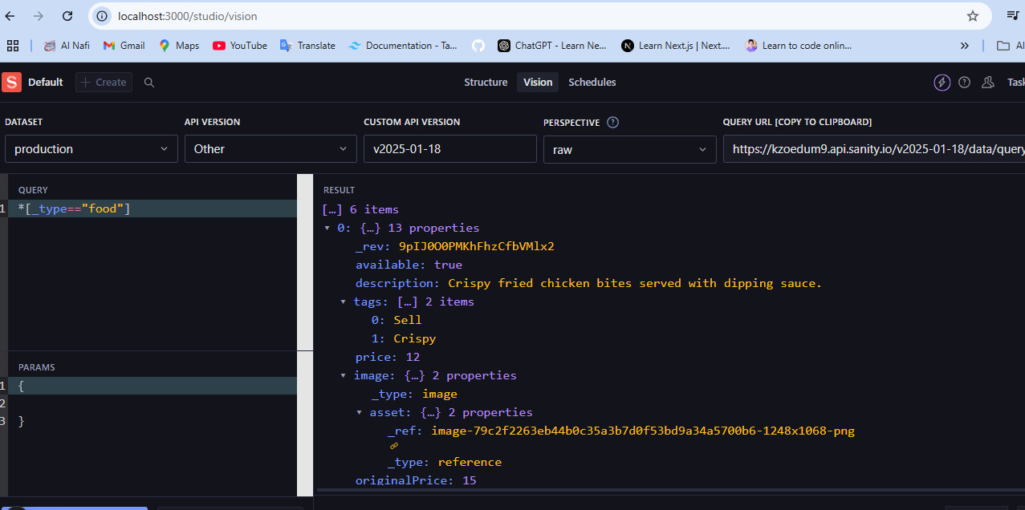

**Step4: I didn’t find any migration file with my template so I used the migration script from template 1. So i saved the file as JSON and imported it into Sanity using its built-in functionality through my hackathon repo by making a script folder in src then adding a mjs file that takes the JSON to sanity.**

**Step5:the provided data was well-structured but not according to my website,so i edited it and changed it . added few fields and removed few of them to get a desired data that aligns with my marketplace requirements, saved it in ndjson format and uploaded it to my sanity project.**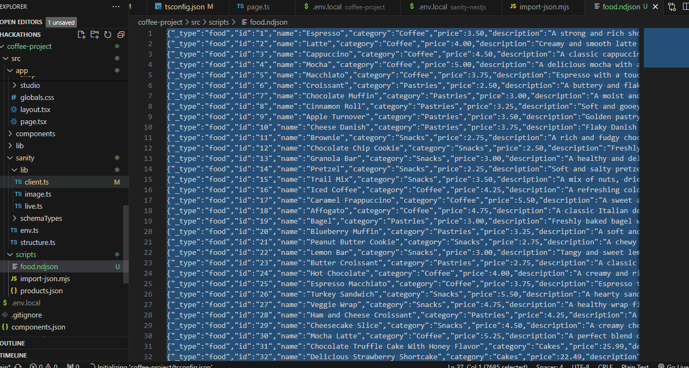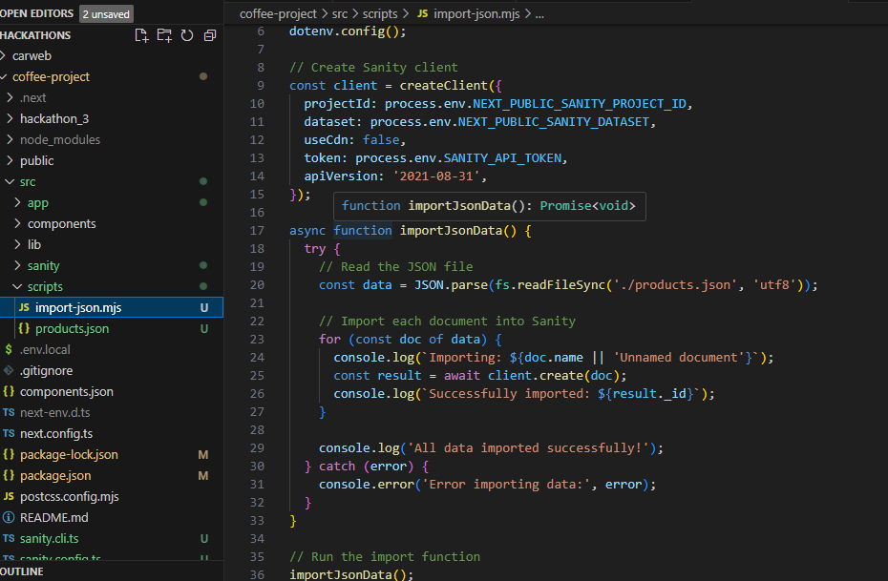

**Step6: fetching data on sanity using query:**

